PROJECT REPORT

ON

MACHINE LEARNING BASED BUYER SEGMENTATION AND INVESTMENT PROFILING FOR REAL ESTATE MARKET INTELLIGENCE

Business Analyst Project

Under the Mentorship of
Unified Mentor

SUBMITTED BY
ISRAR SIDDIQUI

PROJECT DOMAIN
Business Analyst

TOOLS & TECHNOLOGIES
Microsoft Excel | Tableau | Machine Learning | Data Analysis

YEAR OF SUBMISSION 2026
Project Title
Machine Learning Based Buyer Segmentation and Investment Profiling for Real Estate Market Intel

Objective:
The objective of this project is to segment real estate buyers based on their demographic, financial and behavioral characteristics using machine learning-based clustering. The analysis aims to identify distinct buyer segments, understand their investment and loan preferences, and provide data-driven recommendations for targeted marketing and improved customer profiling.

Data Description
The dataset used in this project contains information about 2,000 real estate customers and 21 variables. The dataset includes demographic, geographic, financial, acquisition, and customer-related attributes. These variables help in understanding customer characteristics and identifying different buyer segments.
Key information includes age, gender, country of residence, client type, acquisition preference, financial indicators, referral source, loan application status, customer satisfaction, and cluster assignment.

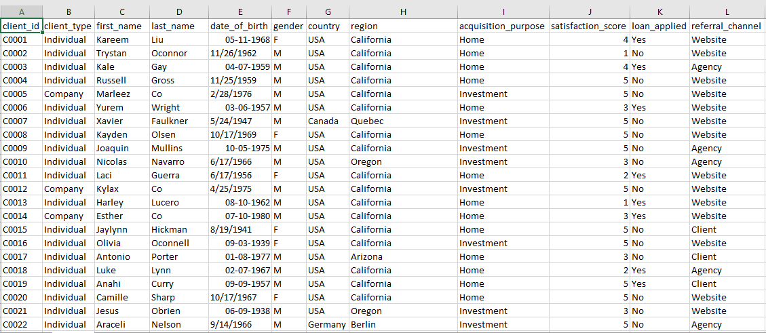
Figure 1: Sample View of the Original Data Real Estate Customer Dataset

Data Cleaning & Preprocessing
Before performing customer segmentation, the dataset was checked and prepared to ensure data quality. Duplicate records were checked, and no duplicate records were identified. Missing values were reviewed and addressed where required. Date of Birth values were standardized into a consistent date format.
Customer Age was derived from the Date of Birth information. The age variable was then prepared for further analysis and machine learning-based segmentation. Categorical variables such as client type, country, acquisition preference, and loan application status were also reviewed for consistency.

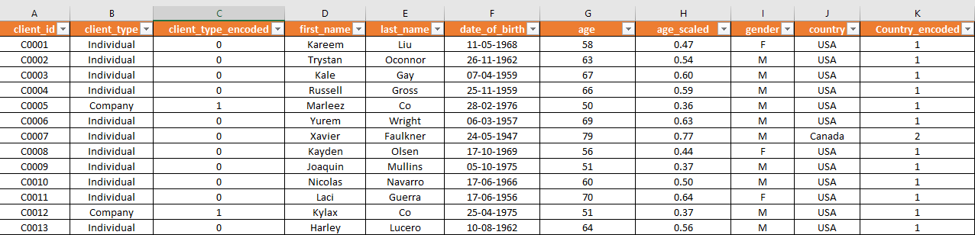
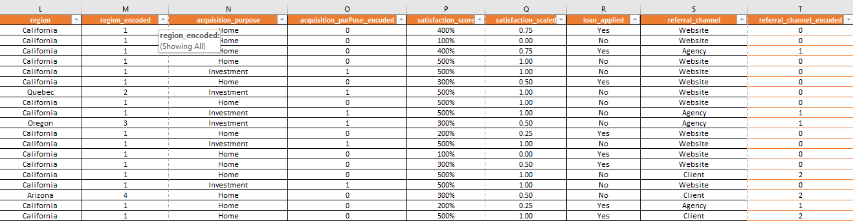
Figure 2: Clenned & Preprocessed Customer Dataset

After completing the data-cleaning and preprocessing steps, the dataset was considered ready for customer segmentation and analysis.

Machine Learning-Based Customer Segmentation
Machine learning-based clustering was used to segment real estate customers according to similarities in their demographic, financial, and behavioral characteristics. The clustering approach grouped customers into distinct segments, allowing the business to better understand differences among buyer groups.
The analysis resulted in three customer clusters: Cluster 0, Cluster 1, and Cluster 2. Each cluster represents a different customer profile based on the characteristics used in the segmentation process.

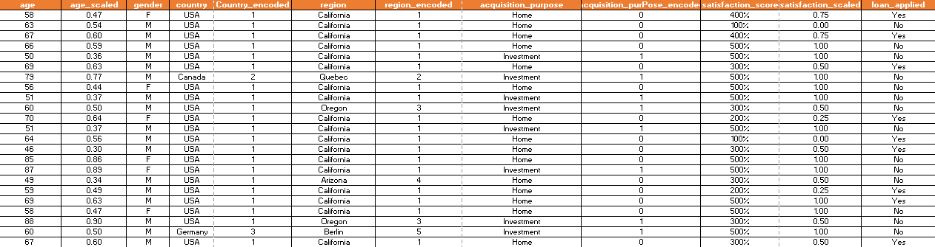
Figure 3: Machine Learning-Based Customer Cluster

The identified clusters were further analyzed using customer count, average age, investment preference, and loan application status. This helped in understanding the characteristics of each buyer segment and identifying the segment with stronger potential for targeted real-estate marketing.
The segmentation provides a data-driven foundation for personalized marketing, investment profiling, customer targeting, and better allocation of marketing resources.

Customer Segmentation Results
The customer segmentation analysis divided the 2,000 real estate customers into three distinct clusters based on similarities in their characteristics.
Cluster 0 contains 707 customers, making it the largest segment. The average age of customers in this cluster is approximately 55.87 years.
Cluster 1 contains 655 customers and has the highest average age of approximately 75.92 years, representing the oldest customer segment.
Cluster 2 contains 638 customers and has the lowest average age of approximately 35.29 years. This segment also shows the highest investment preference (33.70%) and the highest loan application rate (approximately 38.9%).
These results indicate that the three clusters have different customer characteristics and can therefore be approached with different marketing and customer-engagement strategies.

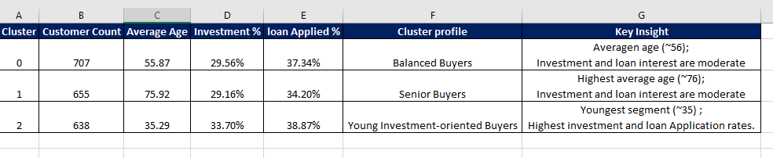
Figure 4: Customer Segmentation Result by Cluster

Dashboard Analysis
A dashboard was developed to provide a visual overview of the real estate customer dataset and the identified buyer segments. The dashboard presents key information through charts and visual summaries, making it easier to understand customer distribution and segmentation patterns.
The dashboard includes Cluster Distribution, Customer Distribution by Country, Client Type Distribution, and Age Distribution. The cluster distribution shows that Cluster 0 has the highest number of customers, followed by Cluster 1 and Cluster 2.
The country-wise analysis provides an overview of the geographic distribution of customers, while the client-type analysis highlights the distribution between Individual and Company customers. The age distribution further helps in understanding the demographic characteristics of the customer base.
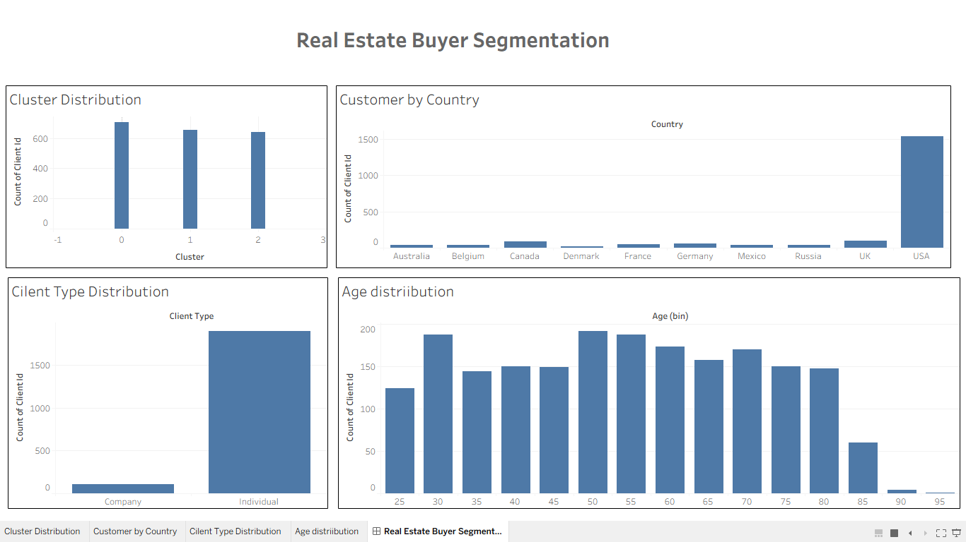
Figure 5: Tableau Dashboard – Real Estate Customer Segmentation

Overall, the dashboard provides a clear and interactive view of the customer data and supports data-driven decision-making for real-estate customer target.

Cluster Analysis
The three customer clusters were analyzed using customer count, average age, investment preference, and loan application status. This comparison helps identify the key characteristics and pot ential business value of each customer segment.
Cluster 0 is the largest segment, with 707 customers and an average age of approximately 55.87 years. Its investment preference is 29.56%, while the loan application rate is approximately 37.3%.
Cluster 1 contains 655 customers and has the highest average age of approximately 75.92 years. Its investment preference is 29.16%, and the loan application rate is approximately 34.2%.
Cluster 2 contains 638 customers and has the lowest average age of approximately 35.29 years. It has the highest investment preference at 33.70% and the highest loan application rate at approximately 38.9%.

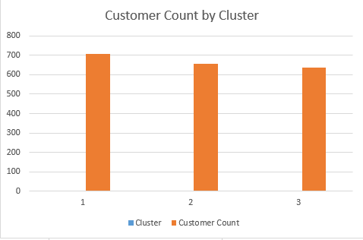

Overall, Cluster 2 demonstrates comparatively stronger investment and financing interest, making it an important segment for targeted real-estate marketing.

Key Insights
The analysis provides several important insights into the real estate customer base. Cluster 0 is the largest customer segment, containing 707 customers, indicating a significant and relatively balanced buyer group.
Cluster 1 has the highest average age of approximately 75.92 years, suggesting that this segment may require more age-appropriate communication and property offerings.
Cluster 2 is the youngest segment, with an average age of approximately 35.29 years. It also records the highest investment preference (33.70%) and the highest loan application rate (approximately 38.9%) among the three clusters.
These findings suggest that customer needs and preferences vary across segments. Therefore, a single marketing strategy may not be equally effective for all customers. Cluster-based and personalized marketing can help improve customer targeting and marketing efficiency.

Business Recommendations
Based on the customer segmentation and cluster analysis, the following recommendations can help improve real-estate marketing and customer targeting:
1. Prioritize Cluster 2: Since Cluster 2 has the highest investment preference and loan application rate, it should be a key target for investment-focused property campaigns.
2. Provide Financing Options: Loan-related offers, flexible financing plans, and suitable loan assistance can be promoted particularly among customers showing stronger loan application behavior.
3. Use Personalized Marketing: Different communication and property offers should be designed for different customer clusters instead of applying the same marketing strategy to all customers.
4. Develop Age-Based Strategies: Cluster 1, with its higher average age, may benefit from simpler communication and property options aligned with the requirements of older buyers.
5. Optimize Marketing Resources: Marketing budgets can be allocated according to the potential and behavior of each segment, helping reduce inefficient or generic marketing expenditure.
6. Continuously Monitor Customer Segments: Customer preferences can change over time, so segmentation should be reviewed periodically as new customer data becomes available.

Target Customer Segment
Based on the cluster analysis, Cluster 2 can be considered the primary target segment for investment-focused real-estate marketing. This cluster consists of 638 customers with an average age of approximately 35.29 years.

Cluster 2 has the highest investment preference (33.70%) among the three segments and also records the highest loan application rate (approximately 38.9%). These characteristics indicate relatively stronger interest in investment opportunities and property financing.

Therefore, real-estate businesses can prioritize Cluster 2 for investment property campaigns, financing offers, digital marketing, and personalized property recommendations.

Marketing Strategy
The customer segmentation results support a differentiated marketing strategy for each buyer cluster. Instead of using a single approach for all customers, marketing campaigns can be customized according to the characteristics and preferences of each segment.
Cluster 2 should receive greater focus for investment-oriented campaigns, digital marketing, property investment opportunities, and financing-related offers because of its higher investment and loan application rates.
Cluster 0, being the largest segment, can be targeted with a broader range of residential and investment property options. Personalized offers based on customer preferences can help improve engagement.
Cluster 1, with its higher average age, can be approached through clear communication, suitable property options, and customer-support-oriented marketing.
Overall, a cluster-based personalized marketing strategy can help improve customer engagement, reduce inefficient marketing expenditure, and increase the effectiveness of real-estate campanies.

Limitations of the Analysis
This analysis is based on the available customer dataset and the variables included in it. The results may be influenced by the quality, completeness, and accuracy of the provided data.
The customer segments identified through clustering represent patterns within the available dataset and may change if additional customer information or new data is introduced. The analysis also focuses on selected demographic, financial, and behavioral variables and may not capture every factor that influences real-estate purchase decisions.
Therefore, the findings should be considered as data-driven guidance for customer targeting rather than fixed predictions of individual customer behavior.

Conclusion
This project successfully used machine learning-based customer segmentation to analyze real-estate buyers and identify distinct customer groups. The analysis divided 2,000 customers into three clusters based on their characteristics and preferences.
The cluster analysis showed meaningful differences between the customer segments. Cluster 2, with an average age of approximately 35.29 years, showed the highest investment preference and loan application rate, making it a key segment for targeted investment and financing campaigns. Cluster 0 was the largest segment, while Cluster 1 represented the oldest customer group.
The findings demonstrate that customer segmentation can help real-estate businesses understand buyer behavior, improve customer profiling, personalize marketing campaigns, and allocate marketing resources more effectively.
Overall, the project provides a data-driven framework for buyer segmentation and investment profiling, supporting more targeted and informed real-estate marketing decisions.

Future Scope
The project can be further improved by incorporating additional customer, financial, property, and transaction-related data. A larger and more diverse dataset could help produce more robust customer segments.
Future analysis could also include advanced machine learning techniques for predicting customer investment behavior, property preferences, and financing requirements. Real-time customer data could be integrated to continuously update customer segments.
Further improvements could include developing personalized property recommendation systems, predictive lead scoring, customer lifetime value analysis, and automated dashboards for ongoing business monitoring.
These enhancements could help real-estate businesses move from descriptive customer segmentation toward predictive and prescriptive analytics.

Tools & Technologies Used
* Microsoft Excel – Data cleaning, preprocessing, calculations, and cluster analysis.
* Tableau – Interactive dashboard creation and data visualization.
* Machine Learning – Clustering – Customer segmentation based on customer characteristics.
* Data Analysis – Analysis of demographic, financial, investment, and loan-related attributes.
* Microsoft Word – Project report preparation and documentation.

Final Project Outcome
The project successfully developed a data-driven approach for understanding and segmenting real-estate customers. The analysis identified three distinct customer clusters and evaluated their demographic, investment, and loan-related characteristics.
The project demonstrated how Excel, Tableau, data analysis, and machine learning-based clustering can be combined to transform raw customer data into meaningful business insights.
The resulting customer segments can support targeted marketing, investment profiling, personalized customer engagement, and more efficient allocation of marketing resources.
Overall, the project provides a practical framework for real-estate market intelligence and data-driven decision-making.

